Ball of Light Meditation
The chakras are located along the spine, but they also extend to the front of our bodies, excluding the crown and the base. Each of the chakras, the second through the sixth has an opposite chakra in the front of the body along the abdomen. The sixth chakra has three. The rear sixth chakra located at the occipital in the back of the head, the middle sixth chakra is located between the third eye and the occipital sixth chakra.
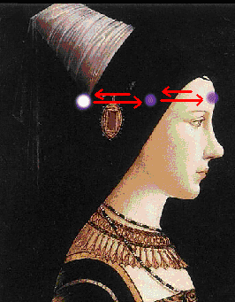 | To perform the meditation, visualize a small ball of bright light the size of a ping-pong ball and light up a chakra on your spine with it and pass it to the front chakra directly opposite it and light it up, then pass it back to the chakra on your spine. Keep passing it back and forth to each chakra, then move up or down to the next chakra (whichever one you want to work with). The illustration on the left shows an example with the sixth chakra.
You can either visualize the ball as white-gold light or the color of the chakra you are working with.
You can also connect the crown to the base. I found the energy center located in the perineum to be especially powerful with this. Just pass it up and down.
Now another interesting thing one can do with this is to connect with another person and this greatly enhances telepathy. For example, passing the ball back and forth from their heart chakra to yours will tell you about the other persons emotional experiences and character.
To interrogate someone, pass the ball of light from your third eye to their third eye, back and forth.
Now, it is obvious you can, with experience invade others privacy and this also includes your own- just something to be aware of if you dont want anyone in your personal business. In that case, close down your chakras, if someone does this against your will.

© Copyright 2005, Joy of Satan Ministries;
Library of Congress Number: 12-16457

