yoga positions

HANDSTAND
Adho Mukha Vrksasana
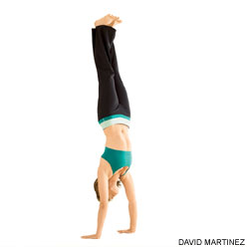
Like its inverted cousins such as Forearm Balance and Headstand, a major obstacle to Handstand is a natural fear of falling. So the basic pose will be described with the heels supported against a wall. Make sure that there are no hanging pictures or other decorations on the wall directly above you.
(ah-doh moo-kah vriks-SHAHS-anna) adho mukha = face
downward (adho = downward; mukha = face)
vrksa = tree
Step by Step
Perform Adho Mukha Svanasana (Downward-Facing Dog Pose) with your fingertips an inch or two away from a wall, hands shoulder-width. If your shoulders are tight, turn your index fingers out slightly; otherwise arrange them parallel to each other. If you're uneasy about this pose, you're not alone. To ready yourself for and secure yourself in this inversion, firm your shoulder blades against your back torso and pull them toward your tailbone. Then rotate your upper arms outward, to keep the shoulder blades broad, and hug your outer arms inward. Finally spread your palms and press the bases of the index fingers firmly against the floor.
Now bend one knee and step the foot in, closer to the wall (we'll say it's the left leg), but keep the other (i.e. right) leg active by extending through the heel. Then take a few practice hops before you try to launch yourself upside down. Sweep your right leg through a wide arc toward the wall and kick your left foot off the floor, immediately pushing through the heel to straighten the left knee. As both legs come off the ground, engage your deep core abdominal muscles to help lift your hips over your shoulders. Hop up and down like this several times, each time pushing off the floor a little higher. Exhale deeply each time you hop.
Hopping up and down like this may be all you can manage for now. Regularly practice strengthening poses, like Adho Mukha Svanasana and Plank Pose. Eventually you'll be able to kick all the way into the pose. At first your heels may crash into the wall, but again with more practice you'll be able to swing your heels up lightly to the wall.
If your armpits and groins are tight, your lower back may be deeply arched. To lengthen this area, draw your front ribs into your torso, reach your tailbone toward your heels, and slide your heels higher up the wall. Squeeze the outer legs together and roll the thighs in. Hang your head from a spot between your shoulder blades and gaze out into the center of the room.
To start stay in the pose 10 to 15 seconds, breathing deeply. Gradually work your way up to 1 minute. When you come down, be sure not to sink onto the shoulders. Keep your shoulder blades lifted and broad, and take one foot down at a time, each time with an exhalation. Stand in Uttanasana for 30 seconds to 1 minute. We tend to kick up with the same leg all the time: be sure to alternate your kicking leg, one day right, next day left.

SHOULDERSTAND
Salamba Sarvangasana
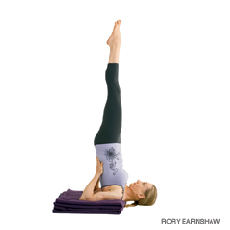
(sah-LOM-bah sar-van-GAHS-anna)
salamba = with support (sa = with
alamba = support)
sarva = all
anga = limb. There are variations of Shoulderstand that are "unsupported" =niralamba, pronounced near-ah-LOM-bah)
Step by Step
Fold two or more firm blankets into rectangles measuring about 1 foot by 2 feet, and stack them one on top of the other. You can place a sticky mat over the blankets to help the upper arms stay in place while in the pose. Then lie on the blankets with your shoulders supported (and parallel to one of the longer edges) and your head on the floor. Lay your arms on the floor alongside your torso, then bend your knees and set your feet against the floor with the heels close to the sitting bones. Exhale, press your arms against the floor, and push your feet away from the floor, drawing your thighs into the front torso.
Continue to lift by curling the pelvis and then the back torso away from the floor, so that your knees come toward your face. Stretch your arms out parallel to the edge of the blanket and turn them outward so the fingers press against the floor (and the thumbs point behind you). Bend your elbows and draw them toward each other. Lay the backs of your upper arms on the blanket and spread your palms against the back of your torso. Raise your pelvis over the shoulders, so that the torso is relatively perpendicular to the floor. Walk your hands up your back (toward the floor) without letting the elbows slide too much wider than shoulder width.
Inhale and lift your bent knees toward the ceiling, bringing your thighs in line with your torso and hanging the heels down by your buttocks. Press your tailbone toward your pubis and turn the upper thighs inward slightly. Finally inhale and straighten the knees, pressing the heels up toward the ceiling. When the backs of the legs are fully lengthened, lift through the balls of the big toes so the inner legs are slightly longer than the outer.
Soften the throat and tongue. Firm the shoulder blades against the back, and move the sternum toward the chin. Your forehead should be relatively parallel to the floor, your chin perpendicular. Press the backs of your upper arms and the tops of your shoulders actively into the blanket support, and try to lift the upper spine away from the floor. Gaze softly at your chest.
As a beginning practitioner stay in the pose for about 30 seconds. Gradually add 5 to 10 seconds to your stay every day or so until you can comfortably hold the pose for 3 minutes. Then continue for 3 minutes each day for a week or two, until you feel relatively comfortable in the pose. Again gradually and 5 to 10 seconds onto your stay every day or so until you can comfortably hold the pose for 5 minutes. To come down, exhale, bend your knees into your torso again, and roll your back torso slowly and carefully onto the floor, keeping the back of your head on the floor.

PLOUGH
Halasana
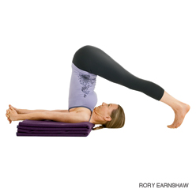
(hah-LAHS-anna)
hala = plow
Step by Step
From Salamba Sarvangasana, exhale and bend from the hip joints to slowly lower your toes to the floor above and beyond your head. As much as possible, keep your torso perpendicular to the floor and your legs fully extended.
With your toes on the floor, lift your top thighs and tailbone toward the ceiling and draw your inner groins deep into the pelvis. Imagine that your torso is hanging from the height of your groins. Continue to draw your chin away from your sternum and soften your throat.
You can continue to press your hands against the back torso, pushing the back up toward the ceiling as you press the backs of the upper arms down, onto your support. Or you can release your hands away from your back and stretch the arms out behind you on the floor, opposite the legs. Clasp the hands and press the arms actively down on the support as you lift the thighs toward the ceiling.
Halasana is usually performed after Sarvangasana for anywhere from 1 to 5 minutes. To exit the pose bring your hands onto your back again, lift back into Sarvangasana with an exhalation, then roll down onto your back, or simply roll out of the pose on an exhalation.

FISH
Matsyasana
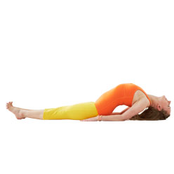
Traditionally Fish Pose is performed with the legs in Padmasana. Since Padmasana is beyond the capacity of most beginning students, here well work either with the knees bent, feet on the floor, or with the legs straight pressed against the floor.
(mot-see-AHS-anna)
matsya = fish
Step by Step
Lie on your back on the floor with your knees bent, feet on the floor. Inhale, lift your pelvis slightly off the floor, and slide your hands, palms down, below your buttocks. Then rest your buttocks on the backs of your hands (and dont lift them off your hands as you perform this pose). Be sure to tuck your forearms and elbows up close to the sides of your torso.
Inhale and press your forearms and elbows firmly against the floor. Next press your scapulas into your back and, with an inhale, lift your upper torso and head away from the floor. Then release your head back onto the floor. Depending on how high you arch your back and lift your chest, either the back of your head or its crown will rest on the floor. There should be a minimal amount of weight on your head to avoid crunching your neck. (For more about this, see the Beginners Tip below.)
You can keep your knees bent or straighten your legs out onto the floor. If you do the latter, keep your thighs active, and press out through the heels.
Stay for 15 to 30 seconds, breathing smoothly. With an exhalation lower your torso and head to the floor. Draw your thighs up into your belly and squeeze.

FORWARD BEND
Paschimottanasana
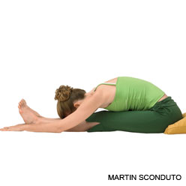
(POSH-ee-moh-tan-AHS-anna)
paschimottana = intense stretch of the west (pashima = west
uttana = intense stretch)
Step by Step
Sit on the floor with your buttocks supported on a folded blanket and your legs straight in front of you. Press actively through your heels. Rock slightly onto your left buttock, and pull your right sitting bone away from the heel with your right hand. Repeat on the other side. Turn the top thighs in slightly and press them down into the floor. Press through your palms or finger tips on the floor beside your hips and lift the top of the sternum toward the ceiling as the top thighs descend.
Draw the inner groins deep into the pelvis. Inhale, and keeping the front torso long, lean forward from the hip joints, not the waist. Lengthen the tailbone away from the back of your pelvis. If possible take the sides of the feet with your hands, thumbs on the soles, elbows fully extended; if this isn't possible, loop a strap around the foot soles, and hold the strap firmly. Be sure your elbows are straight, not bent.
When you are ready to go further, don't forcefully pull yourself into the forward bend, whether your hands are on the feet or holding the strap. Always lengthen the front torso into the pose, keeping your head raised. If you are holding the feet, bend the elbows out to the sides and lift them away from the floor; if holding the strap, lighten your grip and walk the hands forward, keeping the arms long. The lower belly should touch the thighs first, then the upper belly, then the ribs, and the head last.
With each inhalation, lift and lengthen the front torso just slightly; with each exhalation release a little more fully into the forward bend. In this way the torso oscillates and lengthens almost imperceptibly with the breath. Eventually you may be able to stretch the arms out beyond the feet on the floor.
Stay in the pose anywhere from 1 to 3 minutes. To come up, first lift the torso away from the thighs and straighten the elbows again if they are bent. Then inhale and lift the torso up by pulling the tailbone down and into the pelvis.

COBRA
Bhujangasana
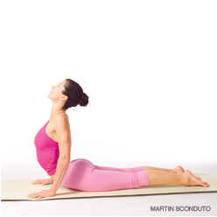

(boo-jang-GAHS-anna)
bhujanga = serpent, snake
Step by Step
Lie prone on the floor. Stretch your legs back, tops of the feet on the floor. Spread your hands on the floor under your shoulders. Hug the elbows back into your body.
Press the tops of the feet and thighs and the pubis firmly into the floor.
On an inhalation, begin to straighten the arms to lift the chest off the floor, going only to the height at which you can maintain a connection through your pubis to your legs. Press the tailbone toward the pubis and lift the pubis toward the navel. Narrow the hip points. Firm but don't harden the buttocks.
Firm the shoulder blades against the back, puffing the side ribs forward. Lift through the top of the sternum but avoid pushing the front ribs forward, which only hardens the lower back. Distribute the backbend evenly throughout the entire spine.
Hold the pose anywhere from 15 to 30 seconds, breathing easily. Release back to the floor with an exhalation.

LOCUST
Salambhasana
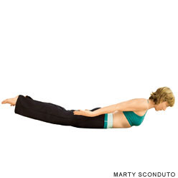
Grouped among the so-called baby backbends, which includes Dhanurasana (Bow Pose) and Sea Monster Pose (described in the Variations section below), it is an unassuming pose that, like other seemingly simple poses, is actually a lot more interesting and challenging than it appears at first glance.
(sha-la-BAHS-anna)
salabha = grasshopper, locust
Step by Step
For this pose you might want to pad the floor below your pelvis and ribs with a folded blanket. Lie on your belly with your arms along the sides of your torso, palms up, forehead resting on the floor. Turn your big toes toward each other to inwardly rotate your thighs, and firm your buttocks so your coccyx presses toward your pubis.
Exhale and lift your head, upper torso, arms, and legs away from the floor. Youll be resting on your lower ribs, belly, and front pelvis. Firm your buttocks and reach strongly through your legs, first through the heels to lengthen the back legs, then through the bases of the big toes. Keep the big toes turned toward each other.
Raise your arms parallel to the floor and stretch back actively through your fingertips. Imagine theres a weight pressing down on the backs of the upper arms, and push up toward the ceiling against this resistance. Press your scapulas firmly into your back.
Gaze forward or slightly upward, being careful not to jut your chin forward and crunch the back of your neck. Keep the base of the skull lifted and the back of the neck long.
Stay for 30 seconds to 1 minute, then release with an exhalation. Take a few breaths and repeat 1 or 2 times more if you like.

BOW
Dhanurasana
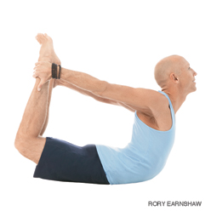
Dhanurasana (Bow Pose)
This pose is so called because it looks like an archer's bow, the torso and legs representing the body of the bow, and the arms the string.
(don-your-AHS-anna)
dhanu = bow
Step by Step
Lie on your belly with your hands alongside your torso, palms up. (You can lie on a folded blanket to pad the front of your torso and legs.) Exhale and bend your knees, bringing your heels as close as you can to your buttocks. Reach back with your hands and take hold of your ankles (but not the tops of the feet). Make sure your knees aren't wider than the width of your hips, and keep your knees hip width for the duration of the pose.
Inhale and strongly lift your heels away from your buttocks and, at the same time, lift your thighs away from the floor. This will have the effect of pulling your upper torso and head off the floor. Burrow the tailbone down toward the floor, and keep your back muscles soft. As you continue lifting the heels and thighs higher, press your shoulder blades firmly against your back to open your heart. Draw the tops of the shoulders away from your ears. Gaze forward.
With the belly pressed against the floor, breathing will be difficult. Breathe more into the back of your torso, and be sure not to stop breathing.
Stay in this pose anywhere from 20 to 30 seconds. Release as you exhale, and lie quietly for a few breaths. You can repeat the pose once or twice more.

TWIST
Ardha Matsyendrasana
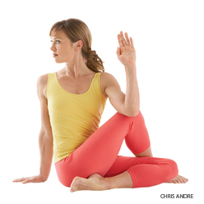
(ARE-dah MOT-see-en-DRAHS-anna)
ardha = half
Matsyendra = king of the fish (matsya = fish
indra = ruler), a legendary teacher of yoga
Step by Step
Sit on the floor with your legs straight out in front of you, buttocks supported on a folded blanket. Bend your knees, put your feet on the floor, then slide your left foot under your right leg to the outside of your right hip. Lay the outside of the left leg on the floor. Step the right foot over the left leg and stand it on the floor outside your left hip. The right knee will point directly up at the ceiling.
Exhale and twist toward the inside of the right thigh. Press the right hand against the floor just behind your right buttock, and set your left upper arm on the outside of your right thigh near the knee. Pull your front torso and inner right thigh snugly together.
Press the inner right foot very actively into the floor, release the right groin, and lengthen the front torso. Lean the upper torso back slightly, against the shoulder blades, and continue to lengthen the tailbone into the floor.
You can turn your head in one of two directions: Continue the twist of the torso by turning it to the right; or counter the twist of the torso by turning it left and looking over the left shoulder at the right foot.
With every inhalation lift a little more through the sternum, pushing the fingers against the floor to help. Twist a little more with every exhalation. Be sure to distribute the twist evenly throughout the entire length of the spine; don't concentrate it in the lower back. Stay for 30 seconds to 1 minute, then release with an exhalation, return to the starting position, and repeat to the left for the same length of time.

STANDING FORWARD BEND
Uttanasana
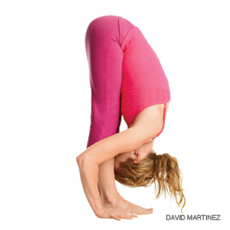
(OOT-tan-AHS-ahna)
ut = intense
tan = to stretch or extend
Step by Step
Stand in Tadasana, hands on hips. Exhale and bend forward from the hip joints, not from the waist. As you descend draw the front torso out of the groins and open the space between the pubis and top sternum. As in all the forward bends, the emphasis is on lengthening the front torso as you move more fully into the position.
If possible, with your knees straight, bring your palms or finger tips to the floor slightly in front of or beside your feet, or bring your palms to the backs of your ankles. If this isn't possible, cross your forearms and hold your elbows. Press the heels firmly into the floor and lift the sitting bones toward the ceiling. Turn the top thighs slightly inward.
With each inhalation in the pose, lift and lengthen the front torso just slightly; with each exhalation release a little more fully into the forward bend. In this way the torso oscillates almost imperceptibly with the breath. Let your head hang from the root of the neck, which is deep in the upper back, between the shoulder blades.
Uttanasana can be used as a resting position between the standing poses. Stay in the pose for 30 seconds to 1 minute. It can also be practiced as a pose in itself.
Don't roll the spine to come up. Instead bring your hands back onto your hips and reaffirm the length of the front torso. Then press your tailbone down and into the pelvis and come up on an inhalation with a long front torso.

TRIANGLE
Utthita Trikonasana
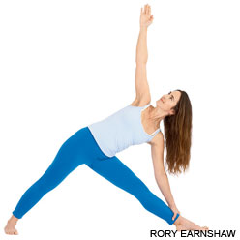
(oo-TEE-tah trik-cone-AHS-anna)
utthita = extended
trikona = three angle or triangle
Step by Step
Stand in Tadasana. With an exhalation, step or lightly jump your feet 3 1/2 to 4 feet apart. Raise your arms parallel to the floor and reach them actively out to the sides, shoulder blades wide, palms down.
Turn your left foot in slightly to the right and your right foot out to the right 90 degrees. Align the right heel with the left heel. Firm your thighs and turn your right thigh outward, so that the center of the right knee cap is in line with the center of the right ankle.
Exhale and extend your torso to the right directly over the plane of the right leg, bending from the hip joint, not the waist. Anchor this movement by strengthening the left leg and pressing the outer heel firmly to the floor. Rotate the torso to the left, keeping the two sides equally long. Let the left hip come slightly forward and lengthen the tailbone toward the back heel.
Rest your right hand on your shin, ankle, or the floor outside your right foot, whatever is possible without distorting the sides of the torso. Stretch your left arm toward the ceiling, in line with the tops of your shoulders. Keep your head in a neutral position or turn it to the left, eyes gazing softly at the left thumb.
Stay in this pose for 30 seconds to 1 minute. Inhale to come up, strongly pressing the back heel into the floor and reaching the top arm toward the ceiling. Reverse the feet and repeat for the same length of time to the left.

CORPSE
Savasana
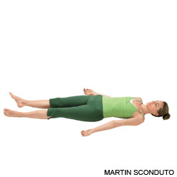
(shah-VAHS-anna)
sava = corpse
This pose is also called Mrtasana (pronounced mrit-TAHS-anna, mrta = death)
Step by Step
In Savasana it's essential that the body be placed in a neutral position. Sit on the floor with your knees bent, feet on the floor, and lean back onto your forearms. Lift your pelvis slightly off the floor and, with your hands, push the back of the pelvis toward the tailbone, then return the pelvis to the floor. Inhale and slowly extend the right leg, then the left, pushing through the heels. Release both legs, softening the groins, and see that the legs are angled evenly relative to the mid-line of the torso, and that the feet turn out equally. Narrow the front pelvis and soften (but don't flatten) the lower back.
With your hands lift the base of the skull away from the back of the neck and release the back of the neck down toward the tailbone. If you have any difficulty doing this, support the back of the head and neck on a folded blanket. Broaden the base of the skull too, and lift the crease of the neck diagonally into the center of the head. Make sure your ears are equidistant from your shoulders.
Reach your arms toward the ceiling, perpendicular to the floor. Rock slightly from side to side and broaden the back ribs and the shoulder blades away from the spine. Then release the arms to the floor, angled evenly relative to the mid-line of torso. Turn the arms outward and stretch them away from the space between the shoulder blades. Rest the backs of the hands on the floor as close as you comfortably can to the index finger knuckles. Make sure the shoulder blades are resting evenly on the floor. Imagine the lower tips of the shoulder blades are lifting diagonally into your back toward the top of the sternum. From here, spread the collarbones.
In addition to quieting the physical body in Savasana, it's also necessary to pacify the sense organs. Soften the root of the tongue, the wings of the nose, the channels of the inner ears, and the skin of the forehead, especially around the bridge of the nose between the eyebrows. Let the eyes sink to the back of the head, then turn them downward to gaze at the heart. Release your brain to the back of the head.
Stay in this pose for 5 minutes for every 30 minutes of practice. To exit, first roll gently with an exhalation onto one side, preferably the right. Take 2 or 3 breaths. With another exhalation press your hands against the floor and lift your torso, dragging your head slowly after. The head should always come up last.

